**Insurance Claims Project**

* Imported the file and merge to get 360-degree view .
* Rearrange the date , datatype to get view and do manipulation task on it.
* If some of the claims was unreported by police we just create flag(1,0) for such claim so we can easily identify such cases.
* To not get any trouble while manipulation we just imp uted null values with mean for continuous and mode for categorical.
* Then I created a new column in data for age of customer and categorize it in Children ,Youth, Adult and Senior.
* Now Analyse the date on basic of Segment and Average Claim amount

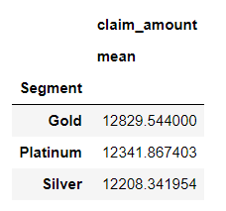

From here we get to know the avg. claim amount for each segment is nearly same.

* Now trying to know total claim amount on incident causes .before next planning month October

So that we can modify our plans.

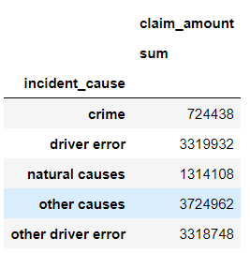

From this we get to know that maximum claim amount goes on other causes

* Here we just analyse Adult categories from state TX, DE and AK for driver related issues.

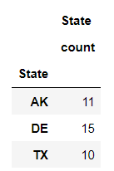

We can se that no. of such issues from these State.

* Analysing data of gender and segment on basic of claim amount so we can fix the gap if there is.

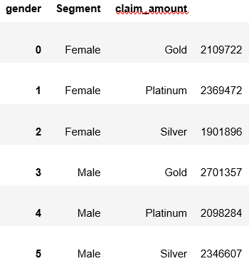 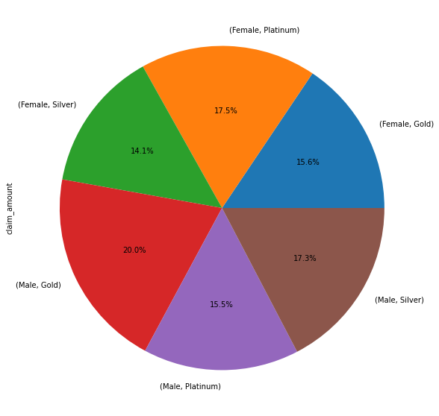

From here we get to known that in segment wise claim amount

* Gender which claim most for any driver related issues

 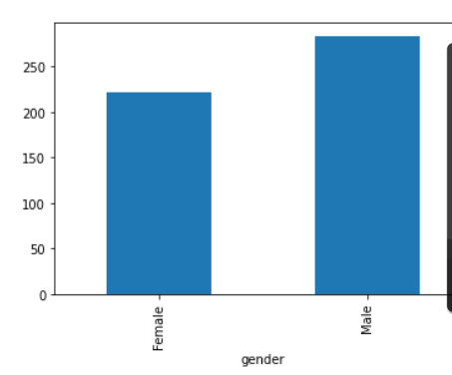

We can easily see male has maximum claim.

* On basic of max. fraudulent policy claims.

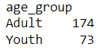 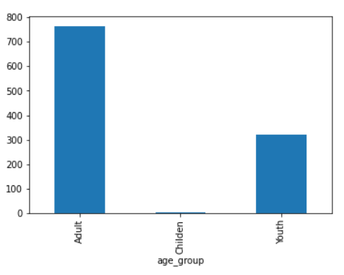

We can easily figure out adult has fraudulent policy claim.

* Analysing monthly trend of the total amount that has been claimed by the customers.

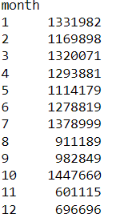 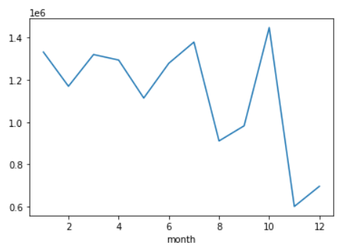

* Analysing avg. claim amount on basis of gender and age with respect to fraudulent statement.

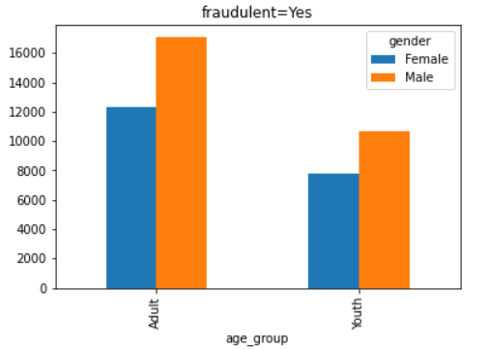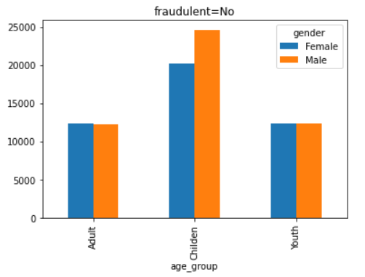

Here we can see on basic fraudulent .

* Claimed amount with respect to gender.

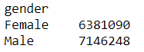 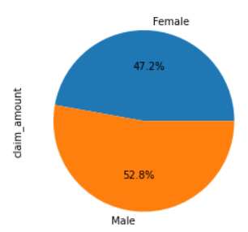

We can easily see that male member has claim more than female.

* Trying to figure out some relation between segment and age group.

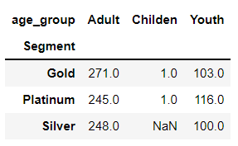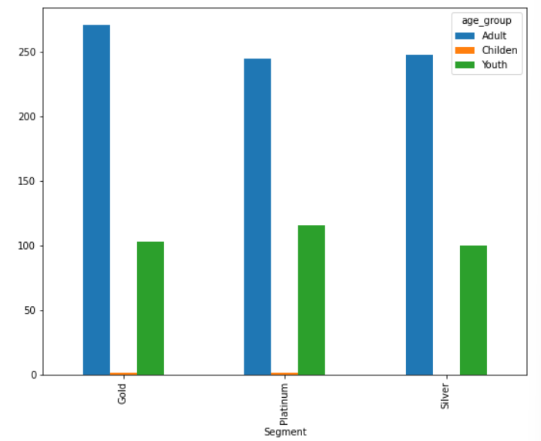

Adult are taking maximum no of any segment policy.

* Trying to figure out total no. of policy claimed as per age group.

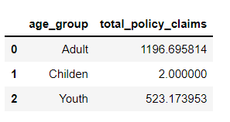

Maximum policy claimed by adults

* Spend on no of policy clamied.

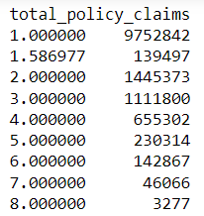 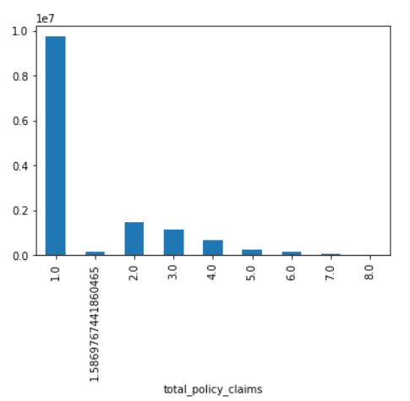

* Company should reduces the claim amount for “Other causes” because company spending maximum amount in this category.
* While looking on Fraudulent data . company should Assign team or strict rule for this because approx. 23% of total claim was Fraud claim and this might be a reason of increase in claim cases than past year.
* We can notice that In month of October claim amount is maximum.
* Average claim amount for male is more than female(approx. 5%).
* Company should promote policy among Youth because it is half the no. of total policy by Adult.and also for senior people age group.